1.The strain in a 1D truss element is given by ε = ∂u/∂x. Mount the corresponding matrix B in terms of nodal coordinates x1 and x2.

clear all

clc

syms x1 x2 xi

C = [x1; x2];

B = simplify(compute_B(C, xi));

function B = compute_B(C, xi)

nnodes = size(C, 1);

ndof = 1;

dN = lin2_derivs(xi);

J = C'*dN;

dNdX = dN*inv(J);

for i = 1: nnodes

c = (i-1) * ndof;

B(1, c+1) = dNdX(i,1);

end

end

function dN = lin2_derivs (xi)

n = [ 1/2 - xi/2

1/2 + xi/2];

dN = [diff(n, xi)];

end

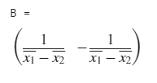

2. Mount the matrix B for a three-node bar element given thenodal coordinates x1, x2 and x3.

clear all

clc

syms x1 x2 x3 xi

C = [x1; x2; x3];

B = compute_B(C, xi);

function B = compute_B(C, xi)

nnodes = size(C, 1);

ndof = 1;

dN = lin3_derivs(xi);

J = C'*dN;

dNdX = dN*inv(J);

for i = 1: nnodes

c = (i-1) * ndof;

B(1, c+1) = dNdX(i,1);

end

end

function dN = lin3_derivs (xi)

n = [ xi*xi/2 - xi/2

xi*xi/2 + xi/2

1 - xi*xi];

dN = [diff(n, xi)];

end

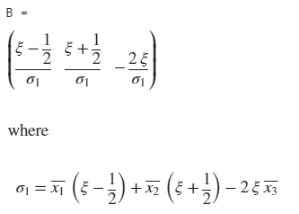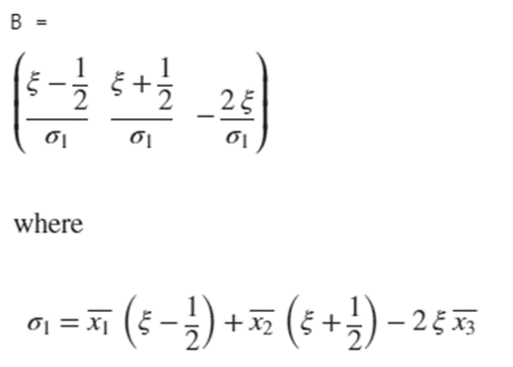

3. Find an expression for the matrix B of a three-node bar element located in 2D space as a function of the Jacobian and the local coordinate ξ. Consider ε = ∂u/∂s wheres is the curviline arco ordinate along the bar path.

clear all

clc

syms x1 x2 x3

syms y1 y2 y3

syms xi

C = [x1 y1; x2 y2; x3 y3];

B = compute_B(C, xi);

function B = compute_B(C, xi)

nnodes = size(C, 1);

ndof = 2;

dN = lin3_derivs(xi);

J = (C'*dN);

dNdX = dN * (J/(norm(J)*norm(J)))';

for i = 1: nnodes

c = (i-1) * ndof;

B(1, c+1) = dNdX(i,1);

B(2, c+2) = dNdX(i,2);

end

end

function dN = lin3_derivs (xi)

n = [ xi*xi/2 - xi/2

xi*xi/2 + xi/2

1 - xi*xi];

dN = [diff(n, xi)];

end

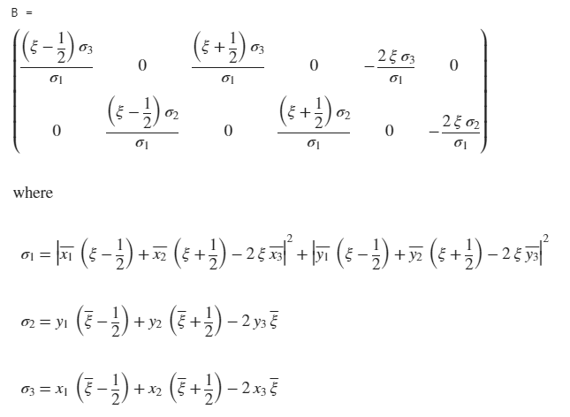

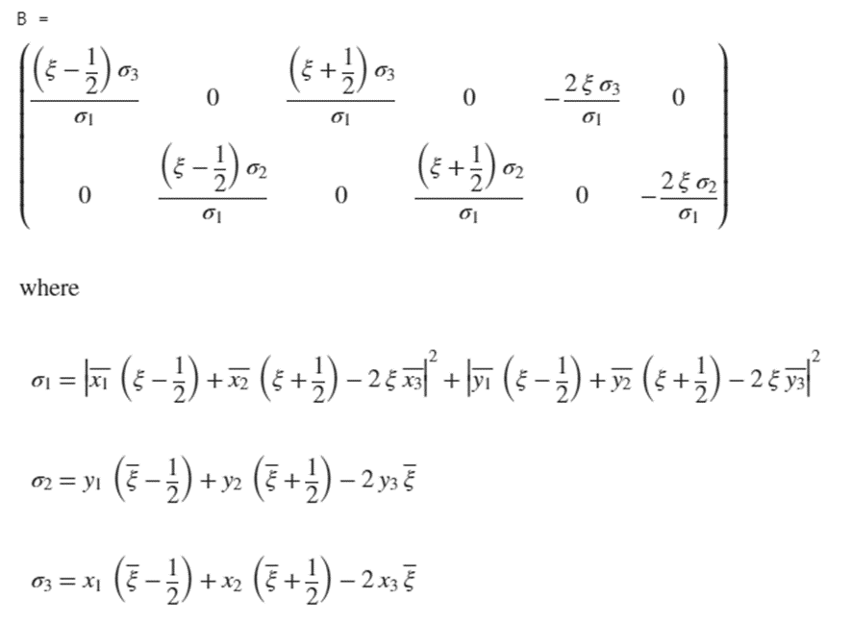

4.Find the matrix B for a three-node triangular element given nodal coordinates(x1,y1),(x2,y2) and (x3, y3). Why matrix B is constant along the element and what does it imply?

clear all

clc

syms x1 x2 x3

syms y1 y2 y3

syms xi eta

C = [x1 y1; x2 y2; x3 y3];

B = compute_B(C, xi, eta);

function B = compute_B(C, xi, eta)

nnodes = size(C, 1);

ndof = 2;

dN = tri3_derivs(xi, eta);

J = C'*dN;

dNdX = dN/J;

for i = 1: nnodes

c = (i-1) * ndof;

B(1, c+1) = dNdX(i,1);

B(2, c+2) = dNdX(i,2);

B(3, c+1) = dNdX(i,2);

B(3, c+2) = dNdX(i,1);

end

end

function dN = tri3_derivs (xi, eta)

n = [ 1 - xi - eta

xi

eta];

dN = [diff(n, xi) diff(n, eta)];

end

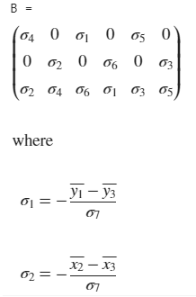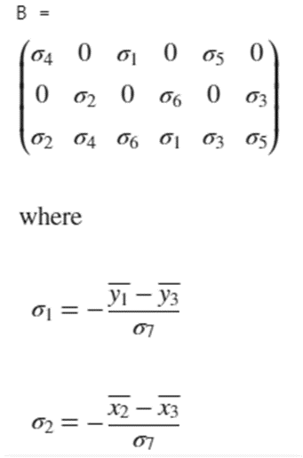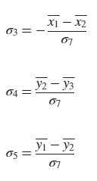

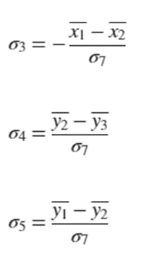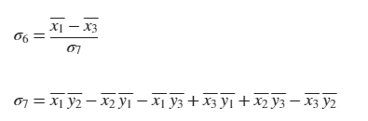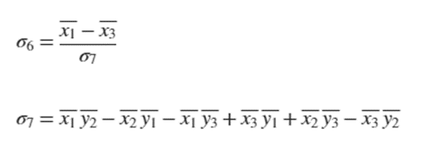

5. For the quadrilateral element shown below, given the vector of nodal displacements U, find the strain components at point(ξ,η) = (−1√3,1√3). U = [0.0 0.0 0.01 0.01 0.015 0.015 0.0 0.015]

clear all

clc

syms xi eta epsilon

x = -1/sqrt(3);

y = 1/sqrt(3);

C = [0 0; 4 2; 4 4; 0 2];

U = [0.0 0.0 0.01 0.01 0.015 0.015 0.0 0.015];

b = compute_B(C, xi, eta);

B = subs(b, [xi eta], [x y]);

d = B * U';

D = vpa(d, 5);

function B = compute_B(C, xi, eta)

nnodes = size(C, 1);

ndof = 2;

dN = quad4_derivs(xi, eta);

J = C'*dN;

dNdX = dN/J;

for i = 1: nnodes

c = (i-1) * ndof;

B(1, c+1) = dNdX(i,1);

B(2, c+2) = dNdX(i,2);

B(3, c+1) = dNdX(i,2);

B(3, c+2) = dNdX(i,1);

end

end

function dN = quad4_derivs (xi, eta)

n = [1.0/4.0 * (1 - xi) * (1 - eta)

1.0/4.0 * (1 + xi) * (1 - eta)

1.0/4.0 * (1 + xi) * (1 + eta)

1.0/4.0 * (1 - xi) * (1 + eta)];

dN = [diff(n, xi) diff(n, eta)];

end

